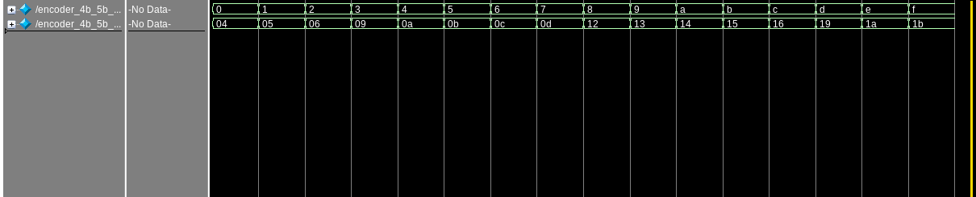
4b_5b_encoder testbench
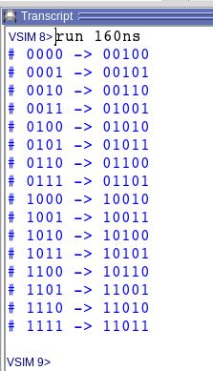
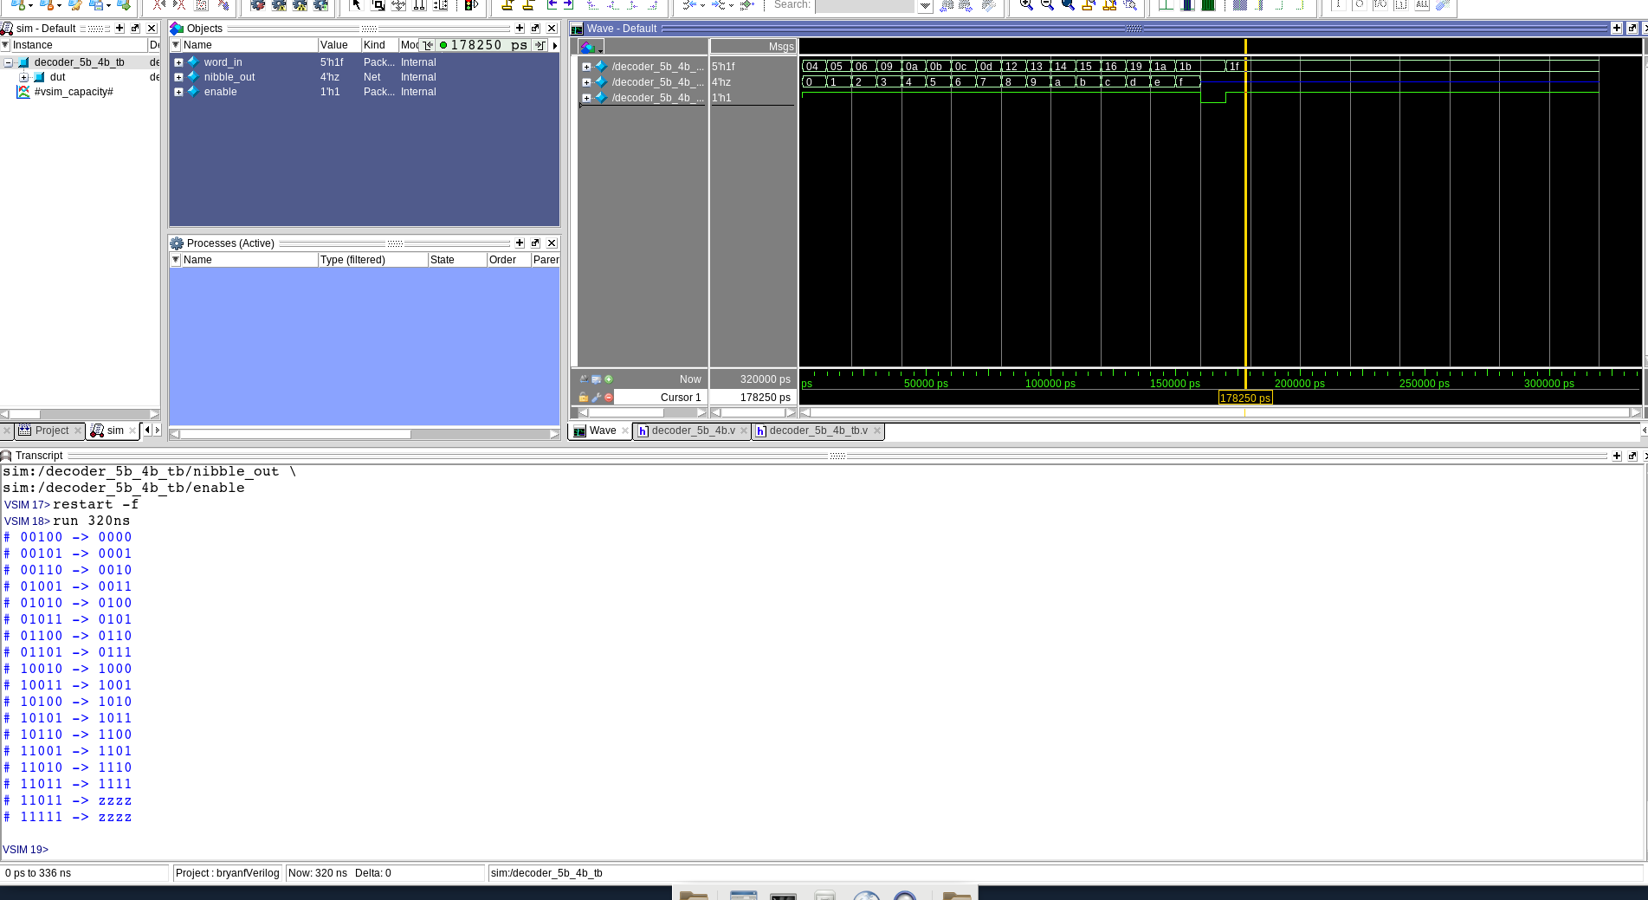

Decoder_5b_4b testbench
Comma Detector testbench (comma = 10_1000_1110)

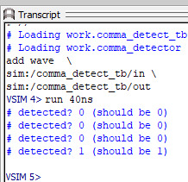

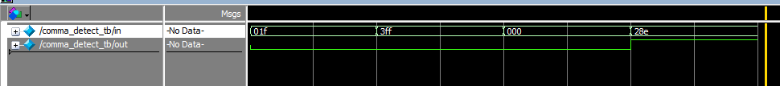

decoder_10b_8b testing
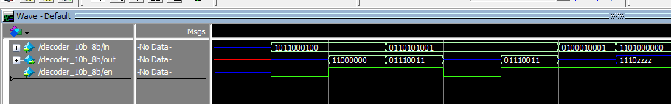

4b_up_counter which resets automatically at 10 and on reset input
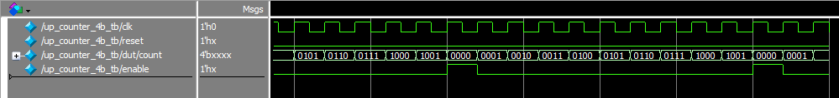

Synthesized Schematic
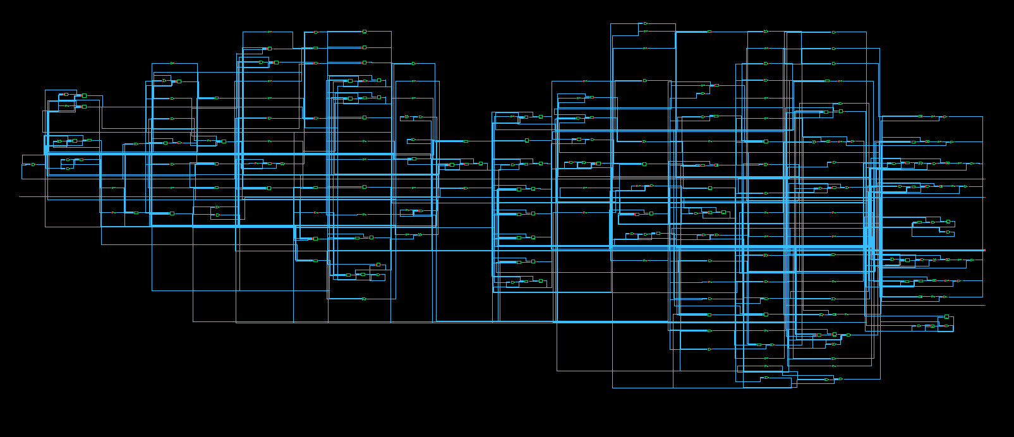
Innovus Place and Route
Geometry verification
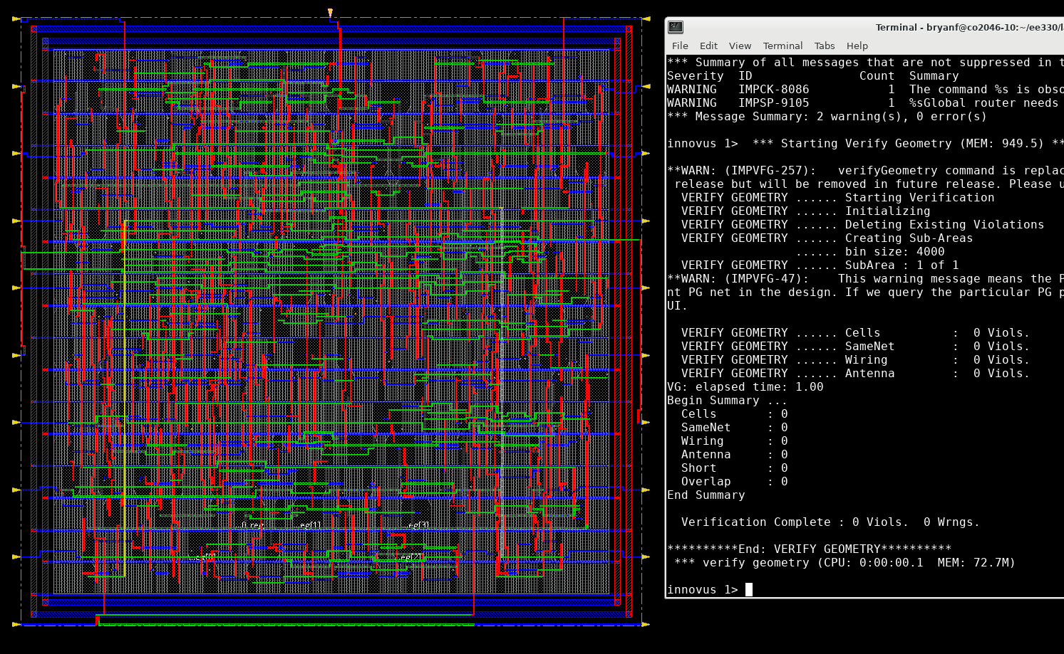
Verify Connectivity
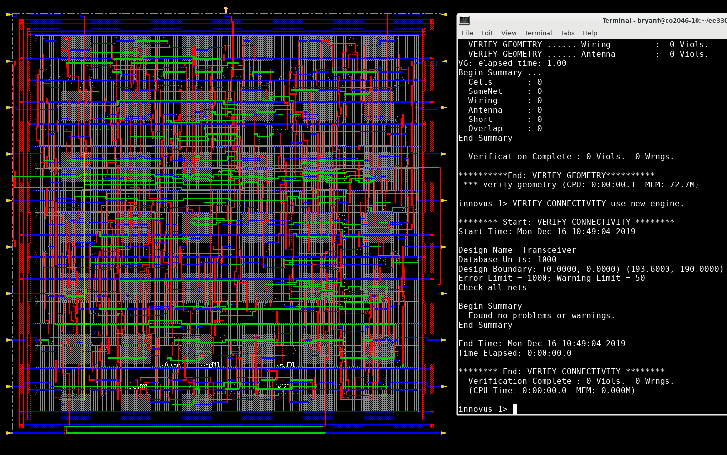
DRC succeeds
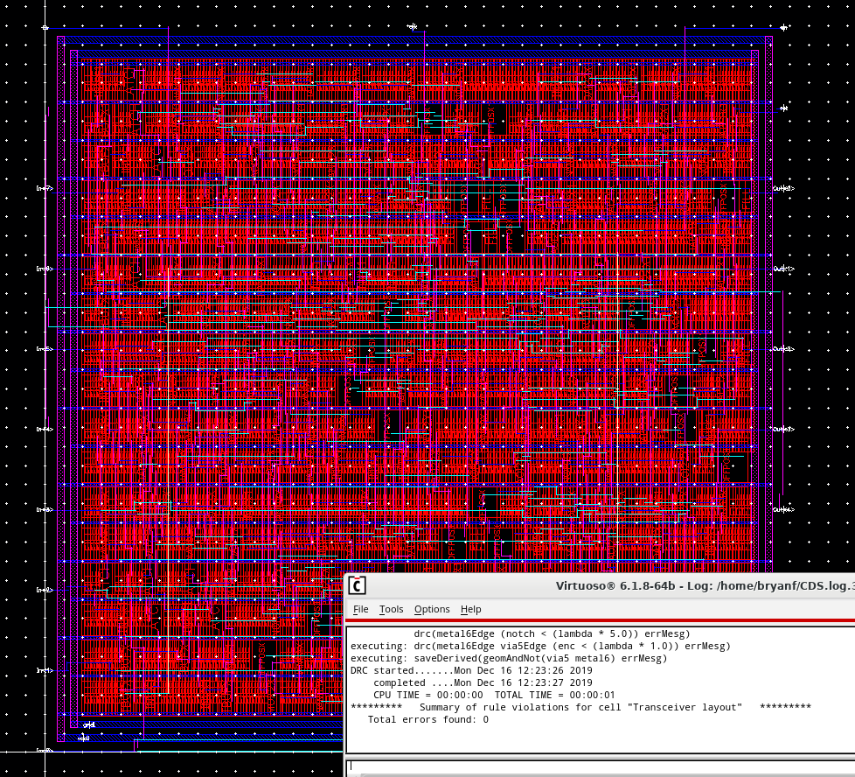

Final Layout
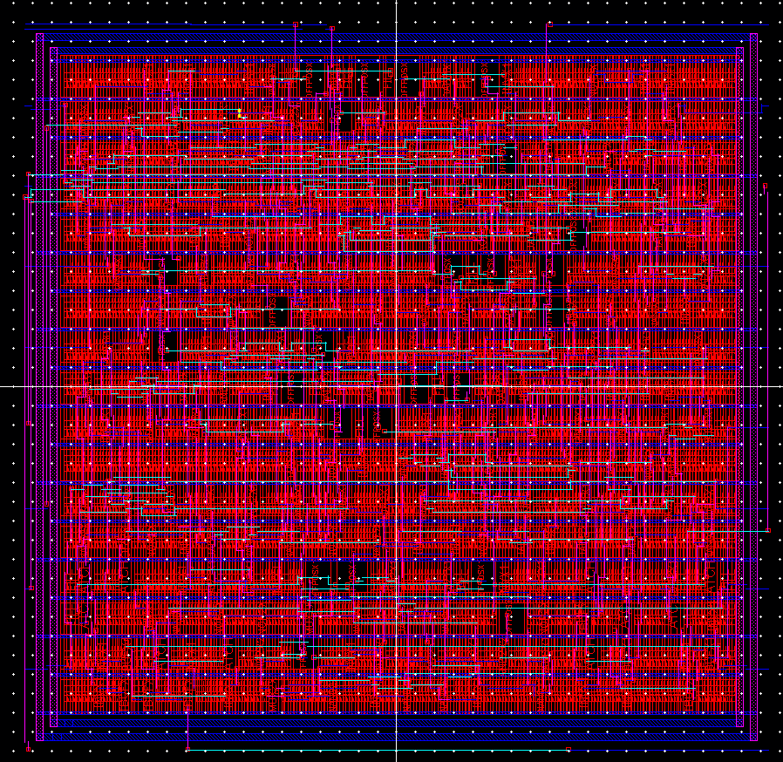

LVS succeeds
